Homework 1 CS205 Introduction to Artificial Intelligence

Yizhuo Instructor: Dr Eamonn Keogh

In completing this homework, I consulted:

Eamonn Keogh (2018), *Blind Search* [Power Point presentation], *http://www.cs.ucr.edu/~eamonn/205/*

**Crossing the River**

Initial State: $\frac{A C C}{cs}$

Goal State: $\frac{A C C}{A C C}$

Operators: Rowing from the upper bank to the lower bank

Rowing from the lower bank to the upper bank

Search Space:

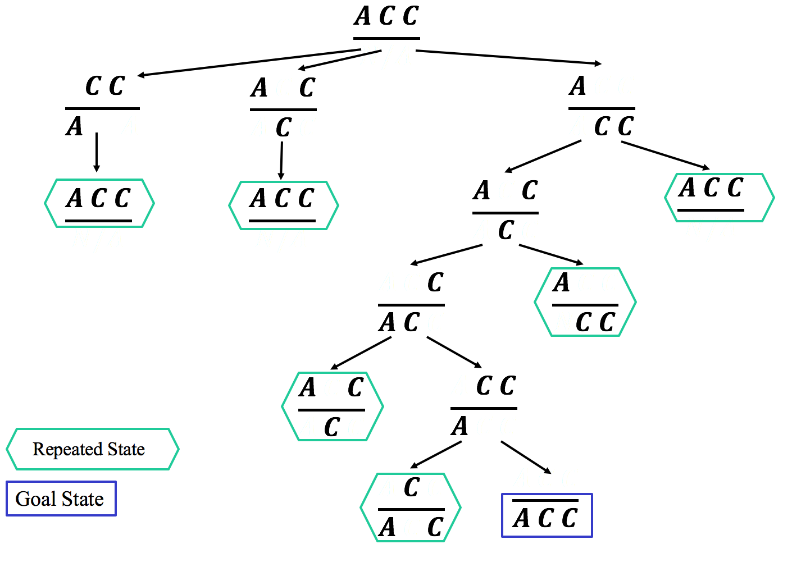

**Exhaustive Search**

1. The standard chessboard owns 8 rows and 8 columns, that means there’s total 64 places for the queens. If these queens are unordered, we have $\left({64 \atop 8}\right)=4426165368$ different arrangements. Given the condition that we can check 1,000 arrangements per second, we need $\frac{4426165368}{1000}＝ 4426165.368$ seconds, approximately 51.22 days.
2. It depends on the node expanded strategies and some luck, time varies between 0.0001 second and 51.22 days. If the solutions are distributed averagely, we need 51.22/12, approximately 4.27 days.
3. Here’s an example from the slides, in 15-puzzles, if we have the following initial state goal state and operators, the problem is impossible to solve.

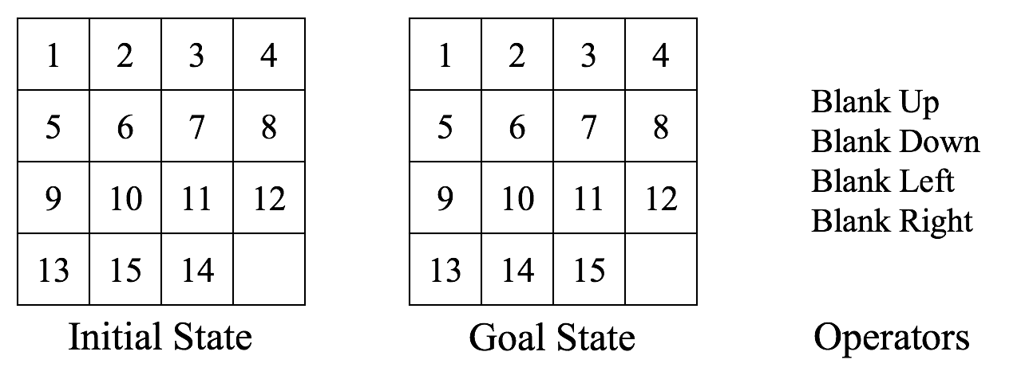

1. Complete search tree for n = 4, excepting the illegal states.

